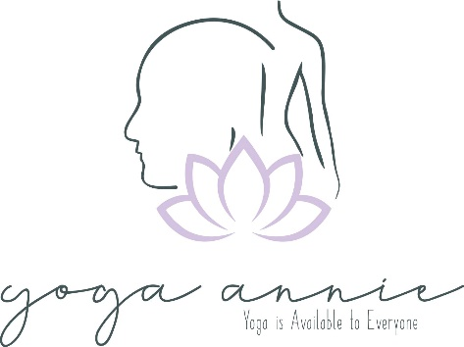
Author, Gill Mines
Yoganidrā:
a Bio-Psycho-Social-Spiritual Framework

for Yoga Therapy
February 1, 2021
Contents

- An Introduction to Yoganidrā
- Crossing the Bridges of Consciousness
- Four Levels of Yoganidrā - the Framework
- Measuring Yoganidrā
- Applying the Yoganidrā Framework
- Overlaying Philosophical Frameworks
- Other Components of Yoganidrā
- Examples of Therapeutic Application
- A Social Approach to Yoganidrā
- Conclusion: Jnana (theoretical) vs. Vijnana (experiential knowledge)

- An Introduction to Yoganidrā
To the modern household yogi, yoganidrā is a guided meditation involving relaxation and redirection of attention to heighten inner awareness. A true practise enables pratyahara and for the yogi to glimpse samadhi, our true nature - infinite consciousness. Awareness of yoganidrā is thanks to significant yoga schools from the 20th – 21st century including Satynanda / Bihar school, Richard Miller / i-Rest, Uma Dinsmore-Tuli and Nilipta Tuli / Total Yoga Nidra, Kamini Desai / Amrit Institute and Swami Veda Bharati of the Himalayas, to name a few.
It would be remiss of me at this point to not state that where possible I have tried to omit the direct teachings of Satyananda – “it is possible that Satyananda Yoga Nidra evolved to ensure the dreamy compliance of participants to submissive control by teachers.” (Wildcroft, 2020) and other so called ‘gurus’ who have tainted these practices. There are so many wonderful, reputable yoganidrā teachers to learn from, and so to them I am thankful.
Yoganidrā, Transcendence vs Transformation: During yoganidrā, the conscious mind subsides, body-mind relaxes, spontaneous pratyahara (/sleep) occurs, but awareness remains, i.e., it is the state of conscious sleep. The mind isn’t afflicted by ego, samskaras (impressions) or vrittis (disturbances), it is devoid of shakti – this state is known as samādhi (Muktibodhananda,1985).
I agree with Uma Dinsmore-Tuli’s observation that yoganidrā is innate to every being, how could it not be, and therefore with the right guidance is a wholly accessible practise.
“It is both a homecoming and a release, a settling into the deepest layers of our true state of freedom” (Dinsmore-Tuli, 2020, pg. 432)
Transformation during nidrā can take the form of deep rest, healing, wisdom, release of mental or emotional tensions, liberation from long-held negative beliefs, and is the stepping stone towards transcendence.
Historical Glimpses of Yoganidrā: truly it was a mysterious oral tradition of the gurus up until the 20th century. For a thorough discussion on the roots of yoganidrā, see Birch and Hargreaves 2014.
*Stephen Parker PsyD / Stoma, a prominent pupil of Swami Veda Bharati, explained that Swami Satyananda Saraswati was a pupil of Swami Rama in the late 1960’s. This contradicts Satyananda’s own account in which he outlines that he created the modern form of nidrā, adapting the practise from the tantric nyasa (Saraswati, 1976) As to which prominent swami first introduced the practise to the west is still up for debate, either way the lineage is much the same – mysterious and multifaceted.

- Crossing the Bridges of Consciousness
Our ancient yogi forebearers understood something profound lay beyond waking consciousness, if they could release identification with the thinking mind (citta-vritti). They discovered sleep-states were the bridges to nidrā (Desai, 2017).
Multiple bridges of sleep and brainwave states must be crossed to transcend - these align perfectly with the 4 states of consciousness (Parker et al, 2013):

Jāgrat / Waking State
- Associated with Beta waves (> 13–30 hz), Gamma waves (30–80 hz) being a subset.
- Slower Gamma waves are associated with learning, greater compassion and empathy, and have been seen to increase during meditation, but also experienced in REM sleep (Desai, 2017)

Svapna / Dreaming
- Alpha waves (8–13 hz) indicate deep physical relaxation during waking
- Yogis may cross the Alpha-Theta bridge into dreaming (REM sleep).
- Theta waves (4–8 hz) are associated with concentration, meditation, dreams and hypnogogic state (lucid thought, dreaming, hallucinations), and memory formation.

“What if nothing exists and we're all in somebody's dream?” ― Woody Allen
In the Alpha-Theta border (REM sleep/svapna), we can explore the practices of Tibetan Dream Yoga (and other traditions; Tolteca, Xhosa Sangoma etc.), the ultimate aim being to understand the true nature of mind, and reside in non-dual awareness (Rinpoche, 1998).

Sushupti / Dreamless Sleep
- The bridge of Theta-Delta (≤ 4 hz) represents the state of yoganidrā; awareness in a cave of anahata-cakra with no thought except the awareness of breathing**.
- Experienced as ‘nothingness’, the body sleeping but still receiving external information, the mind silent, the yogi resting as awareness (Desai, 2017).
**Yoga Sutras I.10: abhāva-pratyaya-ālambanā tamo-vr̥ttir-nidra / Sleep is the modification where the mind rests on the darkness that has no impressions. (13)

Turiya / Pure Consciousness
- Once the yogi has truly mastered yoganidrā, this state becomes indistinguishable from turiya: “In the middle of the eyebrows is the place of Shiva [consciousness], there the mind is quiescent. That state is known as turiya or the 4th dimension. There, time is unknown”. Hathayogapradipika, verse 48 (translation by Muktibodhananda, 1985).
- Delta brainwaves flat-rate (Bharati, 2014)

A significant study by Lou and Kjaer et al, looked at the neural correlates of yoganidrā: ‘relaxed meditation’ vs. normal consciousness, using PET and EEG, although dating to 1999, it is still highly relevant today. Similar, later, studies including one by Cahn and Polich (2006) observed the same key learning, that yoganidrā is characterised by a reduction in activity (blood flow) in the anterior cingulate cortex (ACC), dorsolateral prefrontal areas and the cerebellum. Additionally, the brain activity of the yoganidrā group shared similar patterning with that seen during REM sleep/dreaming (theta increase), with the exception, and omission, of the ACC. This represents a reduction in executive function, motor planning, emotional control and reactivity, which tallies with the subjective experience of nidrā (Lou and Kjaer et al, 1999), but suggests nidrā and mindfulness-based practices (which increase executive function) operate on slightly different pathways.

- Four Levels of Yoganidrā – the Framework
The late Swami Veda Bharati, a very senior monk in India’s Swami order (and pupil of Swami Rama of the Himalayas) proposed an important definition for the state of yoganidrā, this included measurable hypothesis for experiential research going forward (Parker et al, 2013).

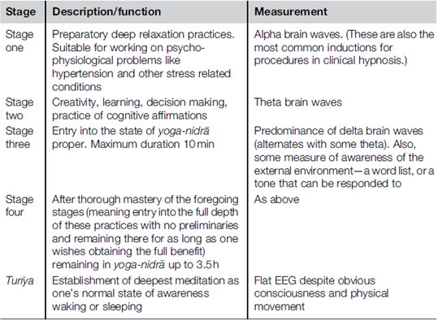
Swami Veda Bharati’s 4 Levels of Yoganidra (Parker, 2019)

I have overlayed the koshas with Bharati’s four levels of yoganidrā, to create a holistic framework for yoga therapy - this is by no means exhaustive, but a starting point.

Yoganidrā Level 1 (YNL1) | The Beta-Alpha bridge | Anna-Prana-Manomaya sheaths

The probability is, that most practitioners of yoga therapy will dwell in YNL1 for a long time.

Characteristics:
- A State of Deep Relaxation
- Returning to Presence: “waking up to the full spectrum of our experience in the present moment… …we rapidly discover is severely edited and often distorted through the routinized, habitual, and unexamined activity of our thoughts and emotions, often involving significant alienation from direct experience of the sensory world and the body” (Kabat-Zinn, 2003)
- Redirection of attention (away from rumination)
- Stress reduction and calming of the Autonomic Nervous System; during yoganidra there’s a shift in autonomic balance to the parasympathetic branch (Markil et al, 2012)
- Self-Healing – psychological, neurological, immunological, and endocrine system coherence support the body’s innate ability to heal (Wahbeh, 2019)
- Improves Heart-Rate-Variability (Markil et al, 2012) – HRV is a measure of autonomic resilience.

Practices for this level
- Shavayatra / 61-points (without visualisation)
- body-scans
- ānāpānasmṛti (mindfulness of breathing)
- pranayama, adjunct to and within the nidrā; diaphragmatic breathing and regulatory pranayama e.g., Ujjayi, Alternate Nostril Breathing, Brahmari, Dirga, and Shabad Kriya for sleep-onset-nidra, as well as gentle breath retention.
- I have had positive outcomes from incorporating brahmari pranayama within trauma-informed nidrā
- breath counting
- Healing phrases (e.g., “I am calm and relaxed” / “I am healing” / “I accept myself as I am” / “May I be filled with healing energy”)
- “Tensing the emotions tenses the body” (Bharati, 2015), therefore to enable relaxation utilise gentle movement (mindful asana), or practices of yin-yoga or restorative-asana can help prepare the body for deep relaxation
- Tensing and Releasing of body parts (progressive relaxation technique) – you can focus on troublesome/habitual areas of tension

Yoganidrā Level 2 (YNL2) | Alpha-Theta bridge | Anna-Prana-Mano-Vijnanamaya

Characteristics:
- Relaxed dreamlike wakefulness or awareness of lucid dreaming (hypnogogic state)
- Concentration
- Creativity: invention, ideas, composing lectures, research papers, poetry and detailed action plans
- Inducing sleep
- Insight: receiving decisions and solutions to problems
- Natural Mindfulness (smṛti) inquiry - making the mind a pleasant place, “who is seeing?”, learning to ‘let go’
- Awareness of emotions, emotional stress, trauma sitting underneath the anna-prana-mano-maya kosha layers
- Dopamine (Kjaer et al, 2002): EEG theta activity coincided with a 65% increase in endogenous dopamine release (in the ventral striatum) during yoganidrā – dopamine is known for its role in positive affect, motivation, and may help delta-wave sleep over time

Practices for this level
- Shavayatra / 61-points with visualisation
- Energetic rotations (more spiritual than body scanning) of energy channels; nadis, meridians, marma, chakras, and pranic rotations; vayus
- Visualisations
- Opposites
- shithali karana (whole body breathing)
- Emotional balancing: resilience, reactivity, traumatic triggers

Yoganidrā Level 3 (YNL3) | True Yoganidrā - Samadhi | The bridge of Theta-Delta | Anna-Prana-Mano-Vijnana-Anandamaya sheaths

Characteristics:
- The yogi is in deep non-REM sleep / Delta brainwave dominance, but is aware of their surroundings
- Liberation/realisation of the true self as infinite consciousness
- Connection (self and universal)
- Embodiment of Patanjali’s sutra “yoga is the stilling of the fluctuations of mind” (Desai, 2017, location 730)
- The Swamis of the Himalayas recommend remaining in this state of yoganidrā for 10 minutes
- Samskaras: deep theta brainwaves (non-REM sleep), give access to unconscious patterns; samskaras, incomplete experiences, and opportunity for change and integration (Desai, 2017)
- Profound Healing - delta brainwave state has been likened to an induced coma (Desai, 2017)
Practices to incorporate at this level
- Guhaa-Pravesha - meditation of the cave in the heart centre (anahata) - no thoughts except the awareness of breathing
- Khechari mudra
- Śāmbhavī mudrā
- Contemplation of the life-force (apana-prana) – see section, ‘the story of Bhusunda’
- Change and integration of Samskaras (see samskara section)
- Sankalpa (can be practised earlier)

See ‘nidra recordings’ file for recording ‘Ocean Nidra’ – transcendence / YNL3

Yoganidrā Level 4 | Turiya | Delta brainwaves flat-rate | Anandamaya Kosha baseline

Characteristics:
- S. V. Bharati “Here the mind simultaneously remains at two levels: (I) One layer of the mind in sleep in the ordinary sense of the word, and (II) a deeper layer of the mind remaining”
- States 1-3 must be mastered
- This state has never been scientifically recorded, Bharati proposes Delta brainwaves flat-line
- Stephen Parker of the Himalayan Institute in conversation commented “It is possible to maintain yourself in a such a relaxed state all the time so that one can enter yoganidrā in a few seconds. Swami Veda [Bharati] we discovered, did this all the time. He was in a state of delta wave sleep, waking and sleeping, 24 hours a day.”

- Measuring Yoganidrā

Stephen Parker’s Measurement Framework (Parker, 2019) proficiently marries together true understanding of the philosophical teachings of yoganidrā and scientific measurement (EEG) to record the brainwave state and levels of yoganidrā.

Other measurement considerations

- Heart-rate-variability (HRV) – is a measure of autonomic nervous system resilience and heart muscle health (‘myocardial stability’). In a study by Markil et al (2012) they found yoganidrā improves HRV
- Cortisol levels and other inflammatory markers
- Levels of yoganidrā and their effects
- Combine measurements with meditator accounts and experiences
- Active controls
- Length of nidrā (long, medium, short)
- Agreement on the specificity of the yoganidrā being taught and measured
- You could measure the effect of different rotations of consciousness

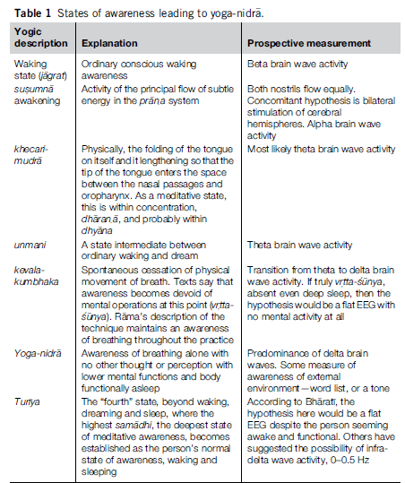
Stephen Parker’s Measurement Framework for Yoganidra (Parker, 2019)

- Applying the Yoganidrā Framework
Importance of Bespoke Yoganidrā: nidrā is an individual experience, exploration and journey to one’s inner source. If we are to stay closely aligned with the ancient roots of this oral practise (Bharati, 2001), it must be shared by an experienced teacher, in an individualised way and optimally private setting for maximum efficacy.
“Interventions are fragile creatures. Rarely, if ever, is the ‘same’ program equally effective in all circumstances.” (Biron et al. 2012).
How to create bespoke nidra sessions? Well, through a combination of your personal practise and abiding by therapy principles: acceptance, attunement, empathy, and kindness. I practise yoganidrā before teaching, it allows for the information I do have about the person to assimilate into my deeper consciousness. And if I’m going into a session with very little background info, I start that session feeling connected to my inner resource, wisdom and thus the solutions arise organically. Uma Dinsmore-Tuli in her phenomenal work ‘Yoni Shakti’ (2020, pg. 323-324) discusses the same importance of personal yoganidrā practise for creativity and problem solving in her work.
What about group nidra? It can be really effective, just like therapeutic group yoga classes, this is discussed in the section: a social approach to yoganidrā.
Recordings vs. In-Person: there is value in the application of audio recordings, due to their accessibility, low cost (as part of a therapeutic intervention) and opportunity for consistent practise. However, studies show that ‘blended interventions’ which include real life contact, as well as home practise, encourage adherence and effectivity (Moszeik et al, 2020).
I agree a student must be introduced to yoganidrā with an experienced teacher/therapist, in-person/online, and that journey must be individualised, as spiritual, meditative practise can heighten psychological issues just as much as it can help them (Fisher, 2010). If the groundwork between therapist and student has already been concreted then sharing audio recordings for home practise, between or after sessions is wholly advisable, as the more often we return to our source, the better.

Rotations of Consciousness
Rotations of consciousness are said to clear the nerve pathways to the brain. Each part of the body has a twin centre in the cerebral white matter known as the ‘homunculus’ (motor/sensory) – similar to a map. As the prana flows through this circuit it relaxes the brain and body (Kumar, 2010).
Body-sensing leads to deep relaxation, via initiation of the relaxation response (Benson, 2000), and the possibility of pratyahara / sense withdrawal. This profound easing can extend to daily life, reducing stress, and feeling more at ease with life’s experiences. This is known as the ‘generalisation effect’ (Novey, 2000).
The original body scan may date as far back as 9th century to the Vimānār-canākalpa, a Vaikhānasa text, which details 18 vital marman points, described again in later texts including, Yogayājñavalkya (pre 12th century) and Vasiṣṭhasaṃhitā of 12th -13th century (Birch, 2018):
““[The yogin] should make the breath, along with the mind, go into these points and hold [them in each one] by means of the mind. By moving [the breath] from point to point, he performs pratyahara “, Vasiṣṭhasaṃhitā 3.74.
The vital marma point rotation (Birch, 2018):
- Big Toes (pādāṅguṣṭha)
- Ankles (gulpha)
- Middle of the Shanks (jaṅghāmadhya)
- Base of the [Tibial] mass (citimūla)
- Middle of the Knees (jānumadhya)
- Middle of the Thighs (ūrumadhya)
- Root of the Anus (pāyumūla)
- Middle of the body (dehamadhya)
- Penis (meḍhra)
- Navel (nābhi)
- Heart (hṛdaya
- Pit of the throat (kaṇṭhakūpa)
- Root of the Palate (tālumūla)
- Base of the Nose (nāsāmūla)
- Eyeballs (akṣimaṇḍala)
- Middle of the Brow (bhrūmadhya)
- Forehead (lalāṭa)
- [Crown of] the Head (mūrdhan).
Shavayatra: “inner pilgrimage through the body”
As it’s known today, ’61-Points’ (Keshaviah, 2016), is a journey of annamaya-pranamaya kosha. The idea is that energy is moved through the 61 energy marma points (sub-chakras) and meridians [/nadis] of the body (Desai, 2017).
The student lies in Śavāsana (Haṭhapradīpikā, 1.34) and the 61 sacred points (marma) of the body are named by number so that the practitioner can learn the sequence with repetition, thus learning to adopt the practise without oral guidance. Another layer to this practise, is visualisation of a blue or golden light at each of the 61 points (Keshaviah, 2016).
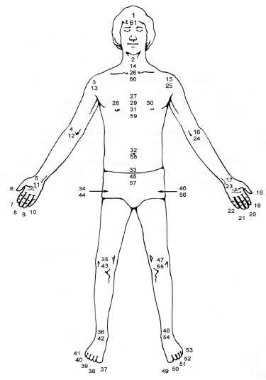
This a traditional rotation of consciousness taught by schools such as the Himalayan, Amrit, and Total Yoga Nidra, and likely derives from the Tantric nyāsa (placing) practices, which were complex rituals performed by Rishi’s, with the aim of unifying body of the yogi with divinity. For example, Mahanirvana Tantra, dating to 17th century describes nyāsa as placing attention, visualisation combined with seed sounds on various energy points in the body (Desai, 2017, loc 284).
Figure 1 61 Points (Keshaviah, 2016).
See ‘nidra recordings’ file for recording of shavayatra

The Homunculus Map and the Primary Somatosensory Cortex: is a reliable map to utilise for body-sensing and rotations of consciousness as scientists tend to agree with the prevailing homunculus model (below) after much study using fMRI (Willoughby, 2021).
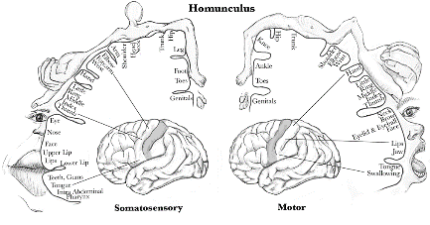
The right cerebral hemisphere represents motor activity on the left side of the body, and the left cerebral hemisphere represents motor activity on the right (Evidence-based Medicine Consult, online resource). The more sensory receptors a body area has, the larger it’s representation, additions to the model may include emphasis on the forehead, deep elbow and wrist joint (Sun et al, 2020).
Figure 2. Motor-Sensory Homunculus - online resource: https://www.ebmconsult.com/articles/homunculus-sensory-motor-cortex
A recent study using MRI by Saadon-Grosman et al (2020), identified somatosensory responsive areas differ between brain regions – figure 3 shows the distribution of body-part representations, manifested in different homunculi, suggesting differing functional roles.
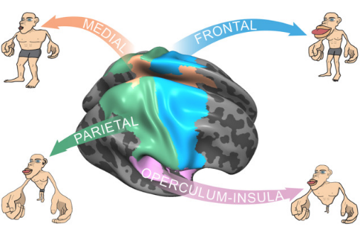
Figure 3. Homunculi by region (source: Saadon-Grosman, 2020)

- Medial: Larger representation of lower limbs related to their substantial role in motor actions (and leg pathologies)
- Parietal: dominance of upper limbs and trunk is related to this region’s role in bodily processing and self-consciousness
- Frontal: dominance of lips and upper limbs, relates to higher order functions like speech, memory, language, attention, planning and embodiment
- Operculum-Insula: representation here suggests the trunk has a significant role with regard to emotional somatosensory processing, body ownership, and visceral properties.
These findings highlight why differing rotations of consciousness should be explored and individualised based on a person’s mental and physical presentation – for example, if the aim of the practise is to empower the student to improve their sense of self, via sensory the aim of the yoganidrā is to empower the student to improve their sense of self, via sensory processing (interoception), thus enabling body ownership, you might focus the rotation on the operculum-insula homunculi.

Feminine Rotations for the Stages of Womanhood: Given that the ancient yogis were usually male, it’s not surprising that modern yogis have felt it necessary to adapt and evolve these practices, making them welcoming of the female body/anatomy. Uma Dinsmore-Tuli, and trainees of the Total Yoga Nidra school, offer a wealth of yoganidrās aimed at women’s health – see Yoni Shakti (Dinsmore-Tuli, 2020) or the https://www.yoganidranetwork.org/ for inspiration.

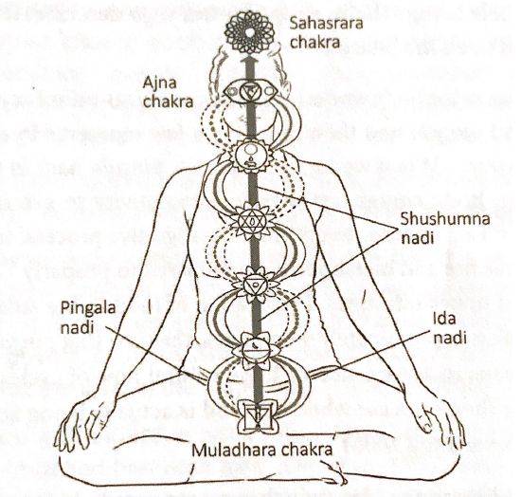
Energetic Rotations (YNL 2-3)
Figure 4 Nadis: Sushumna, Ida and Pingala (Watts, 2018, pg. 27)
Prana pervades everything, and where the mind goes prana flows. Using a combination of mental awareness and breath we can redirect, reinvigorate and re-balance prana – this is a really empowering tool for students who may otherwise feel a loss of control as to their own health and well-being.
Nadis; Sushumna, Ida and Pingala: ida (moon energy) and pingala (sun energy) weave around the central channel sushumna like a double helix, interestingly this kind of marries with the branches of the Autonomic Nervous System – Parasympathetic Nervous System (ida) and Sympathetic Nervous System (pingala). Often, we’ll want to balance the nadis system, by balancing the energy of ida-pingala, so that kundalini (divine energy) is awakened and rises within susuhmna (and the chakra centres). You might incorporate breath, and alternate-nostril-breathing, directing the pranic flow from left-to-right and right-to-left.
See ‘nidra recordings’ file for recording of ‘Ida-Pingala Balancing’
Meridians (jing luo) of Traditional Chinese Medicine/TCM: “the body is animated by the flows of these subtle energies through thousands of subtle but physical channels” (Blair, 2016, pg. 89)
The 6 pairs of meridians are bio-energetic-psycho-spiritual circuits, they overlap the fascial lines of the body, loosely link with organs and are associated with different health issues and emotional states e.g., grief / Lung imbalance or anger / Liver imbalance. (Blair, 2016, see appendix A). An energetic rotation might follow a meridian-pairing pathway (often where one pathway ends, is the beginning of another) combined with breathing (one way qi enters the body) into the vital points, inviting qi energy to flow and remove blockages (stagnation of xue).
Nyasa and the Chakras: the practise of nyasa involves placing vibrational mantra within each chakra centre e.g., Lam (muladhara), Vam (swadhisthana), Ram (manipura), Yam (anahata), Ham (visuddha), Om (ajna), Ng (sahasrara), (Harris, 2019) – this could be practiced instead of, or as an adjunct to the body scan, or another rotation.
Bringing the Energy Down / Grounding: when you observe a certain energy state in a person, you can create a rotation that is unique to them in that moment. Here are examples for grounding:
- Beginning rotations in the feet: I’ll always remember one of my students contacting me after a yoganidrā session to say how much she loved starting the rotation at the feet - this student has battled major depressive disorder for decades.
- Shaura Hall, a yoga therapist and expert in yoganidrā for mental health, suggests for mental health afflictions like addiction, where anxiety is very high, and the mind is hyperactive, starting the rotation at the crown of the head. She spends the first few minutes here naming detailed points of the face and within the brain itself "Base of the skull, middle of the brain, right hand side back of the brain, to the right-hand front brain, front centre of the brain”. Focusing on bringing a person down into their body (Minded, module 11, 2020).

PSYCHOLOGICAL CHANGES AS RELATED
TO YOGA NIDR
Connecting with the Energy of Nature
“All life exists within a sea of vibration, and rhythm is fundamental to all of life. Diurnal, seasonal, lunar, and solar cycles, and the resonant electromagnetic field (EMF) oscillations of our planet make up the symphony of rhythms in which life on Earth exists” (Muehsam, 2014).
Human beings are intricately connected with the energy of the natural world, as we are all one vast ecosystem. During the state of yoganidra we re-connect with universal energy, so it makes sense that the journey towards this state may involve re-connection with the natural rhythms of life around us.
The Elements of Traditional Chinese Medicine: through experiential knowledge the ancient Chinese practitioners realised water, wood, fire, earth and metal were essential material elements of nature. Over time this developed into a holistic theoretical framework, a dynamic system, in which each sub-system (element) can either be in balance ‘moderate qui’, inadequate ‘too little qi’ or ‘too much qi’, hyperactive (Ma et al, 2014).
In the TCM health system, connection underpins everything, this includes our relationship with the external world and nature – i.e., external-internal balance.
The holistic 5 element system of TCM helps us to re-harmonise with nature (Harris, 2019):
- Winter / Water – theme: equilibrium or energy balancing / emotion: fear, courage
- Spring / Wood – theme: growth or creativity / emotion: anger, frustration
- Summer / Fire – theme: connecting with joy / emotion: joy, sadness, loneliness
- Late Summer / Earth – theme: nurture & nourishment / emotion: anxiety, contentment
- Autumn / Metal – theme: letting go / emotion: grief, sadness
When you asses your student, notice if their behaviours or emotions align with the natural energy of the season - you can explore this with the client directly. If they do align, you can empower them to notice this, which will help normalise their feelings, and encourage self-study and reflection.
Example: if I were working with a student who presented with fear during winter, I might utilise the qualities of the water element within the nidra. This might include natural sounds or visualisations of natural water; a stream, gentle river, or ocean waves - the energy channels of the body are like rivers and tributaries. Pranayama like coherent breathing or nadi shodhana could be practised before or within the nidra to balance the subtle body.
If they don’t align, say the student presents with anger during summer, suggesting they’re out of sync with nature, perhaps their growth has been hindered in some way. You might do a series of yoganidras beginning with the element of spring (which relates to where they are energetically), and transverse and progress to the element of summer (joy) - often, underneath anger is sadness.

Sound Healing, Music and Nidrā
Rhythm characterises music, rhythm is the carrier of life-information, and the understanding that music touches our core being, is as old as human consciousness (Muehsam, 2014).
“A person does not hear sound only through the ears; he hears sound through every pore of his body. It permeates the entire being, and according to its particular influence either slows or quickens the rhythm of the blood circulation; it either wakens or soothes the nervous system. It arouses a person to greater passions or it calms him by bringing him peace. According to the sound and its influence a certain effect is produced. Sound becomes visible in the form of radiance. This shows that the same energy which goes into the form of sound before being visible is absorbed by the physical body. In that way the physical body recuperates and becomes charged with new magnetism” Hazrat Inayat Khan (2002)
Percussion instruments like singing bowls, rain-makers, wind-chimes etc. bring rhythm and life to a nidra, as do pre-recorded sounds of nature - I prefer to record my own whenever I find myself in nature.
Uma Dinsmore-Tuli is infamous for her musical nidras which have a lullaby-like quality to them, utilising soothing rhymical energy - lullabies are cross-cultural, used to soothe babies to help them sleep, as well as fostering bonding and feelings of social safety. These bio-physiological and somnogenic (sleep inducing) effects are relevant to adults as well (Akkermanna et al, 2021). Suggesting lullaby-like musical nidra could be helpful with sleep disorders; measurable by EEG (sleep wearable headbands), as they help increase theta activity (Akkermanna et al, 2021), and encourage a sense of safety/sattva - useful also for populations who, for whatever reason, lack social and/or autonomic nervous system grounding.
Alternatively, vocal sound, singing, humming-bee breath or chanting can add rhythm and depth to a yoganidra, and the student can partake. If your client’s goal is self-expression you might include brahmari pranayama at energy points (marma) or chanting. For a client looking to relinquish feelings of guilt, a focus on Viśuddha (throat chakra) with chanting of the seed mantra Ham, may help alleviate blocked energy.
Coherence and Coherent Breathing
Breath rhythm, heartbeat, and the brain are intimately connected, and relate to thoughts, emotions and our psycho-spiritual state (Muehsam, 2014) – coherence (induced by coherent breathing) is the harmony of these internal rhythms. During nidra you might play Stephen Elliot’s ‘2-Bells’ or a metronome (set to inhale-exhale ratio of 5:5/6:6), helping to consciously employ the phrenic nerve to move the diaphragm in a rhythmical manner, “promoting optimal circulation, improving brain function and nourishing every cell in the body in a positive feedback loop”, Stephen Elliot: https://coherentbreathing.com/.

Inspiration from Ancient Teachings:
There are glimpses of the oral tradition of yoganidra in the ancient texts and sutras, and from these hints we can surmise how our yogi forebearers may have delivered the practise and create our own interpretations – yoganidra level-3.
Khecari-Mudra Culminates in Yoganidrā
“prana which is in the right and left nadis moves in the middle nadi (sushumna) that is the condition for khechari mudra”. Hathayogapradipika, verse 43 (transalation, Muktibodhananda, 1985).
Vyoma chakra is situated in the supportless space between ida/pingala, and meditation here, with tongue curled back (on upper palate) to close sushumna is khechari. This practise is inherited from tantra and assumes the preparatory practices (YNL1-2) have been mastered, the chakras and nadis are clear and balanced (Muktibodhananda, 1985).
“Khechari should be practised until yogic sleep occurs. For one who has attained yogic sleep, time becomes non-existent”
Hathayogapradipika, verse 49 (transalation, Muktibodhananda, 1985).

Śāmbhavī Mudrā and Transcendence: ‘the eyes half open, half closed, and the gaze internal’ is mentioned in multiple yogic texts, including the (12th century) Rājayoga text the Amanaska and the Śāṇḍilya Upaniṣad (2nd-3rd century):
“setting the pupil of the eyes fixed in the direction of radiance [eye brow centre / Sambhavi mudra] results in yoga nidra” (Birch and Hargreaves 2014)
This point relates to Ajna /Guru chakra, the place where ida/pingala terminate, the centre of consciousness, once kundalini shakti has risen, awakening this chakra, yoganidra may spontaneously occur. Trataka (firm gaze) develops the skill of Śāmbhavī, when practised with ujjayi (Muktibodhananda, 1985).

Yoga-taravali of Acharya Shankara, translated by Swami Narasimhananda (2019), describes the path to samadhi, by practise of the bandhas, purification of the flow of prana within the nadis via a combination of pranayama and breath retention, alongside meditation of the anahata chakra.
“Due to excellent reflection on the indwelling Self, the previous attachments of persons go away and they attain a state of conscious sleep, yoga-nidra, which makes them give up all thoughts of this universe.” verse 24 (Narasimhananda (2019).

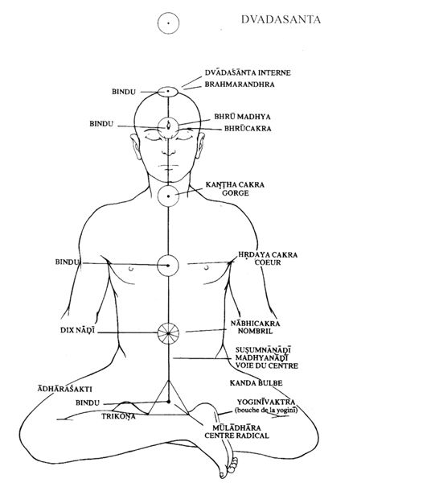
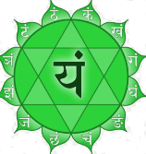
Yoga-Vasistha - the story of Bhusunda
Dvādaśānta
Prana
Apana
terminates at anahata
arises at anahata
arises at dvādaśānta
terminates at dvādaśānta
Figure 5 Contemplation of the Life Force (66)
Swami Veda Bharati, of the Himalayan institute, recommended familiarisation with the sutra Yoga-Vasistha and in particular the story of Bhusunda – see translation by Venkatesananda (1993) verses VI. 1:14 – 26.
The importance of this text is clear from the discourse between Vasistha and Bhusunda regarding the contemplative practices required for self-realisation as endless consciousness (yoganidrā) – snippets from VI. 1:14 – 26:
- The highest wisdom is self-knowledge
- Let go of mental conditioning and identification with the body
- Affirmation: “I am at peace within my heart, and I am not affected by the events of the world” (VI.1:20)
- World is illusory: “it rises and it ceases in the twinkling of an eye like ripples in the ocean” … …neither real nor unreal. The only reality is the movement of energy in the cosmic consciousness” (VI.1:21-22)
- Contemplation of the life-force (prana – see figure 5) and practise of the kumbhakas overcomes sorrow and leads to self-realisation as infinite consciousness / samadhi (VI.1:23 - 25):
“When the outgoing air moves up to the nose tip, recaka, when it moves to the dvadasanta (12 fingers above the forehead, or in front) this is external recaka.
Prana ceases movement, apana does not rise this is external-kumbhaka
Internal kumbhaka is when the apana flows inward, without the prana rising. This apana may rise to the dvadasanta, internal expansion, internal-puraka…
…Hold that space where prana is consumed by apana, and apana is consumed by prana”

See file ‘nidra recordings’ and ‘the story of Bhusunda’

- Overlaying Philosophical Frameworks
To create bespoke, holistic and therapeutic yoganidrās for our clients, we can utilise the ancient philosophical frameworks – the koshas have already been applied to the levels of yoganidrā.
The Yamas and Niyamas; the ethical teachings for living well, are intrinsic to our being, therefore we can weave their teachings and contemplation within yoganidrā. The yamas help a client relate to others or their external experience, while the niyamas can help them to explore inner observances and realisations about themselves.
Example, ahimsa (yama): non-harming i.e., kindness should come from the inside-out. Nidra itself is a form of self-love, but you can also weave in ahimsa in the form of non-judgemental awareness, affirmations of kindness, acceptance, well-being e.g., “may I accept myself just as I am”. Through sankalpa, inviting the person to discover what they truly need and / or how they’d like to share their kindness with others.
Second example, yoganidrā is the embodiment of svadhyaya / self-study (niyama). During nidra we can call on our inner teacher (wisdom), to help us resolve internal afflictions or challenges and bring into question long held beliefs (samskaras) about ourselves. Resting as awareness helps us detach long enough to see things with fresh eyes.
The Gunas, balancing prakriti (shakti) and the Polyvagal Theory: the three components of prakriti, namely sattva (harmony/calm), tamas (stability/lethargy) and rajas (activity/anxiety) manifest as environmental, physiological and psychological experience (Sullivan-Robertson, 2020). Ultimately the sattvic practise of yoganidrā helps us to detach from prakriti, harmonising the gunas, and realising the true self as infinite consciousness.
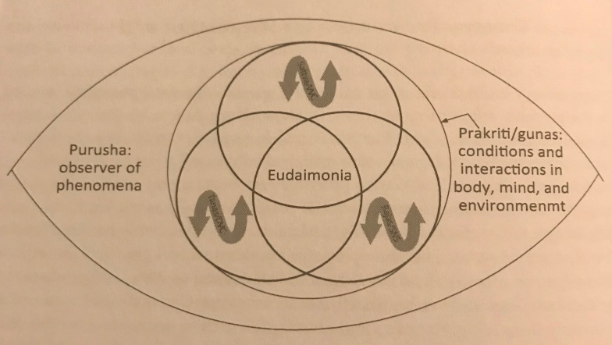
Sullivan et al (2018), have created an extraordinary framework (fig. 6) which marries the ancient Gunas system with modern science, the Autonomic Nervous System and Polyvagal Theory (Stephen Porges). The framework explicates, Sattva (harmony) aligns with the Ventral Vagal Complex (social engagement), Tamas (inertia) aligns with Dorsal Vagal Complex (vegetative), and finally Rajas (activity) lines up with the Sympathetic Nervous System (mobilisation).
Figure 6. Yoga and Polyvagal Theory: Gunas and Neural Platforms (Sullivan, Schmalzl, Moonaz, Taylor, Porges 2018)
As therapists we embody purusha/the observer, and identify a person’s temperament in that moment or collection of moments. We can apply this observance by determining if nidra is the right pathway, and how we might utilise the practise to recalibrate imbalances.
Example: for a student who wants to build resilience, shifting from a state of rajasic-sympathetic baseline to a sattvic-social-engagement baseline will require a longer-term practise of yoganidrā level 2-3 (theta brainwave state). The aim being to empower them to realise thoughts are temporary, reactions are internally driven and that when they allow themselves to let go and rest as awareness, their reactivity and relationship with external experiences will change or dissipate (theta-delta border), and their well-being will improve.
Yoganidrā level 1 might be appropriate for a tamasic-dorsal-vagal imbalance, in which the client is experiencing misperception or disassociation of the body, by inviting them to non-judgementally experience the body in the present moment, supports interoception and re-evaluation in a sattvic context.

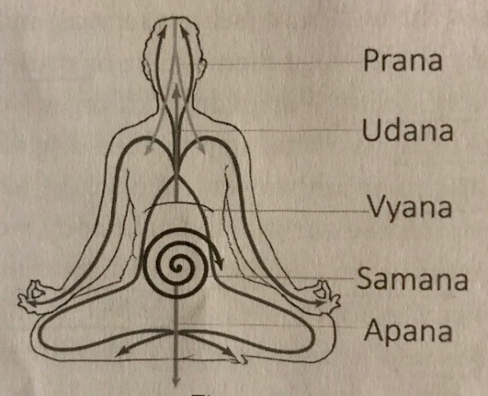
The Prana Vayus (winds) are the subtle forms of pranic movement – figure 7. Prana vayu arises at the anahata chakra and rules upward movement, Apana vayu governs downward and outward. Samana vayu balances prana/apana, and is housed at the naval chakra. Udana vayu manages upward-outward motion, and finally Vyana vayu pervades all the nadis of the body (Watts, 2018).
Figure 7. Prana Vayus (Source: Watts, 2018, pg. 22)
The prana vayus relate to pranamaya sheath and the subtle energy body, and so can be assessed as part of the kosha framework.
Example: apana vayu imbalance may manifest as fear, hypervigilance, rumination, with energy being concentrated in the head – for this the nidra will need to invite grounding (bring the energy down into the body / long slow diaphragmatic breaths), re-connection, and the stabilisation of roots.
The Doshas are an ayurvedic constitutional framework, every person housing their own composition of the dosha-triad; Vatta (air element /energetic/open-minded), Pitta (fire / driven/ fighting spirit), and Kapha (earth and water / stable / strong). For a detailed explanation of the doshas see Charlotte Watts: ‘yoga therapy for digestive health’ (2018). The doshas can help yoga therapists assess whether a person is ready/receptive for yoganidra, as well as helping guide the focus and goal of an individualised nidra.
Example, a person with pitta imbalance will not be ready for the stillness and contemplative nature of nidra even though it’s clear they’re in dire need of deep rest, therefore preparatory practices will be the focus until YNL1 is accessible.

- Other Components of Yoganidrā
This section will discuss other components of modern yoganidra practices, and their impact on therapeutic application.
Samskaras, life’s impressions:
“A samskara is a powerful vibrational energy that arises in consciousness after an external event or when an internal trigger stimulates a thought, sensation or emotion” - Gail Parker.
Culture, family, relationships and our life experiences shape how our energy manifests. Samskaras can be adaptive, meaning the energy will be naturally released by an action (e.g., crying) which equals the nature of the samskara (e.g., sadness). However, maladaptive samskaras signal an unconscious energy blockage somewhere in the psyche and body, perhaps a habit we keep repeating (addiction) or an opinion we can’t let go of (unhelpful belief) – these can become so charged that they dictate our way of being and response to the world. (Parker, 2020)
When we journey deeper in our nidra practise, level 2-3, we’re provided with the opportunity for reconfiguration of samskaras, we release what we no longer need, reaffirm what we do, and create new, positive, nourishing samskaras that lead us towards wholeness. Some of this takes places without any doing, some of it we can intentionally drive with the support of sankalpa.
Sankalpa (intention): A sankalpa is an empowering tool, which offers our students self-efficacy and a sense of control of their well-being through the application of intention. An intention is often repeated near the beginning of practise, and then again during the state of yoganidra or when the student is resting in awareness - it’s believed that a sankalpa will manifest if repeated devotionally. To support this, they should be spoken in present tense, as though they’ve already manifested.
It’s important for the teacher and student to discuss potential intensions before embarking on the practise of nidra, otherwise the student may feel lost if asked to think on the spot and this provides ammunition for self-harming thoughts. If a student is unsure, we can offer guidance based on their therapeutic goals, helping the student to choose a positive intention which encourages growth.
Sankalpa pathways
- A resolve to change a negative samskara (this doesn’t mean fixating on ‘what’s wrong with them’, instead letting go of a defeating habit like self-doubt)
- A resolve to manifest a positive samskara or heart’s desire (supporting perseverance)
- Self-healing
- Present moment intention e.g., rest, tranquillity (yoganidrā level 1) – this is used as a precursor to the full sankalpa in the iRest system (Richard Miller).

Visualisation is powerful – use with care (yoganidrā level 2-3): hypnagogic imagery can naturally arise during nidra, these might manifest as lights, shapes, colours, images, or out-of-body like experiences. It’s important to empower students with this knowledge beforehand, but reiterate that our endeavour is not to attach to these experiences, but recognise you are the passive sky, observing them, as they pass like clouds, through consciousness (Desai, 2017). Lou and Kjaer et al (1999) observed an increase in blood flow (via PET scans) in regions of the brain known to be active in imagery, occipital and anterior parietal cortical regions, during yoganidrā.
The healing power of guided imagery has been found to help boost the immune system, reduce pain, decrease blood pressure, and lessen insomnia (Lusk, 1995).
A basic framework for visualisations:
- Relaxation is key to enabling receptivity of imagination; green and blue colours have been shown to increase the alpha wave, which means the effect of relaxing or relieving stress (Hong et al, 2009).
- Imagery must be supportive to the population/person you are working with (Justice, 2018)
- Share images with a client before guiding them to check for sensitivities and empower them with permission to change the image as they wish, e.g., to their resource (a resource is often discussed in the first therapy session)
- On the return, you might ask the student to visualise the space they’re practising in, bringing them back to the body and earth
- Ask students if they want to share their experience

Opposites and Sensing Emotions: Opposites are a fundamental part of many yoganidra schools, including the iRest system, in particular for trauma recovery “by shifting between opposites, while also experiencing wholeness, you unlearn old patterns of reactive behaviour and rewire new coping strategies – healing” (Richard Miller, 2015, pg. 98)
The neural component of the tool of opposites is to augment ‘habituation’; a neuron fires producing a nerve impulse, which is registered in the brain, but if the same neuron keeps firing over and over, the same signal is no longer registered by the brain leading to relaxation (Kumar, 2010).
For opposites to be effective and not overwhelming, it’s best to establish grounding and safety in yoganidrā level 1 and then progress to yoganidrā level 2 and the inclusion of opposites. You might explore a spectrum of emotions with a client, but finish on something positive, by recalling a felt-sense or memory of joy, safety, peace or well-being.
Yoganidra helps harmonise the autonomic nervous system, meaning restoring emotional health and balance by way of relaxation, concentration, and enabling pratyahara; leading to a realisation of the self as awareness (Dwivedi & Singh 2016).

- Examples of Therapeutic Application
“Sometimes being still is the most powerful thing we can do” - Gail Parker (2020)
Stress, Anxiety and Hypertension: there’s a wealth of research which corroborates yoganidrā’s positive effects on overactive sympathetic nervous systems, offering students the capacity to relax and reduce their sympathetic drive (stress) and reinstate parasympathetic dominance. A basic study by Saraswati & Saraswati (2015) suggests the possibility of over time reinstating a PNS baseline by reducing blood pressure in those with pre-hypertension or stage 1 hypertension. The study looked at YNL1 combined with an Ayurveda therapy Shirodhara (involves gently pouring liquids over the 'third eye') and saw a significant decrease in blood pressure (systolic and diastolic) in 52% of patients.
A more recent study, compared the effects of yoganidrā (YNG) vs. alternate nostril breathing (ANG) amongst essential hypertensive patients (varying ages 21-65) over 4 weeks, and found that the YNG showed a significant reduction in Bp (systolic/diastolic), breath rate, BMI and anxiety (compared with ANG group only saw a reduction in breath rate). (Manik et al, 2016).
Similarly, in a study of students (80 total, male/female 20-30years) already actively practising yoga asana, pranayama and shatkarmas were divided into an active control group (30 students) and an experimental group, who received a daily 30min yoganidrā. A reduction in levels of anxiety and stress were seen in the nidra intervention group (Kumar, 2008).
See file ‘nidra recordings’ – ‘calming nidra for stress reduction’

Sleep Disorder Recovery: writing from personal experience, yoganidrā has helped me improve sleep onset during periods of emotionally challenging inter-personal events. Nidra decreases sympathetic drive, respiratory rate, and helps facilitate the transition from beta to alpha waves (preceding sleep) and could be an adjunct to CBT-I, and help wean people off medication which only “treats” the symptoms (Sharpe et al, 2021).
Nidra is only impactful when it improves sleep quality, and therefore daytime energy and quality of life overall. A small iRest study found sleep time improved, but neither night-time awakenings nor quality of sleep improved (Gutman et al, 2016), suggesting the root cause wasn’t addressed. Probably due to the uniformity of the practise and it was only intended for sleep onset (YNL1).
To address the root cause of any sleep disorder, requires a multifaceted approach. On the one hand sleep disturbance is typically coincided with heightened sympathetic drive and other energy depleting symptomology such as fatigue, emotional irritability, which of themselves effect quality of life. However, if the root cause is not addressed, the sleep disturbance will continue in some form, regardless of whether the symptoms are partly addressed with medication or alternative therapy.
Example structure of a bespoke yoganidrā program for sleep recovery:
- Sleep onset nidra (intended for insomnia too) / YNL1-2
- Morning nidra for energy recovery and rejuvenation / YNL 1-3
- Emotional recovery – daytime practise, getting to the root of the cause /YNL3
Lack of self-efficacy – sleep recovery expert and yoga therapist Lisa Sanfilipino (2019) acknowledge’s the efficacy of yoganidrā, but she does not include it within her therapy protocol because it relies on an external stimulus (a recording or teacher) to reap benefit. I understand this viewpoint, but I believe what nidra offers sleep disorder sufferers, that alternative modalities can’t, is the opportunity to address the deeply entrenched samskaras that manifest as poor behavioural habits, thought patterns and physiological symptoms.

Trauma Informed Yoganidrā: means the therapist has the relevant trauma training and experience to provide trauma sensitive yoganidra – trauma is a spectrum and our clients may present with single event or very complex trauma.
A fundamental element of trauma informed yoganidra is an inner resource; this can be anything which enables the student to feel safe and grounded, and should be discussed with the therapist in detail before beginning any therapeutic practices.
During deep relaxation there will be moments when the student experiences, fear, anxiety, sadness, anger, emptiness perhaps isolation, and here their resource is of upmost importance in countering negative feelings and beliefs (Miller, 2015). On one level we all have a natural re-source, but for students of trauma, this will be hidden, so inviting them to connect with whatever allows them to feel safe, at ease, calm, loved or even joyful, whenever they need to, during the nidra empowers them to feel in control of their experience.
Emphasising down-regulation and grounding: for some stillness can feel threatening, this is usually accompanied by a hypervigilant nervous system, and so nidra isn’t accessible, yet. Safety and grounding must be the foundation, followed by regulatory practices to re-introduce a sense of security and stability within the body-mind. Once the foundation is set, nidra has the potential to be a really important element for healing. For example, with ongoing ethnic or race-based trauma, it is common for people to dissociate from their bodies as an adaptive tactic. This coping strategy may even be inherited, as we now know from epigenetics our bodies can house generational trauma (Parker, 2020). To help reintegrate interoception, recognition of bodily cues and feelings, you might work within YNL1 for a long time with a student focusing on regulatory pranayama, paced and detailed rotations of consciousness and short periods of resting in awareness. Later progressing to more complex YNL2-3 practices in which deeper healing can take place including healing of samskaras.
“As someone with PTSD I find I benefit more from doing the same Yoga Nidra, in particular one that incorporates a focus on parts of the body. This is because it creates a safe zone that I am comfortable with. It also helps to have a voice of a friend – again enabling me to feel safe in a position of vulnerability (lying relaxed, alone and in darkness).
One of the biggest benefits I have found from Nidra is its ability to help me get to sleep, especially when I am on the trajectory to having a ‘trigger episode’ (NB: My PTSD is controlled day to day but often emotions build up and are locked inside and can then unleash without warning causing a deep panic attack, self-harm thoughts or actions). By doing a short yoga nidra before bed it helps alleviate nightmares, helps my body relax and enables me to have a less restless sleep.”
- Kelly (yoganidrā practitioner with complex PTSD)
Richard Miller/ iRest, in his magnificent book ‘The iRest Program for Healing PTSD’ has created a thorough framework for trauma-informed yoganidrā - I recommend reading and assimilating the great depths of this work if you intend to work with trauma and in particular complex trauma (Miller, 2015).

Chronic Pain: yoganidrā is wholly accessible option for people with restricted movement and mobility due to chronic pain.
A pilot study looking into the impact of iRest as adjunct therapy (alongside standard medical care) for veterans with chronic pain, the authors hypothesised a reduction in pain intensity based on findings from similar iRest studies. Albeit a small (male only) study, they found some decrease in pain intensity amongst the study group. Of notable importance was the statistically significant and substantial (32.72% – 41.06%) reductions in pain interference in daily life (Nassif et al, 2014).
Whereas other therapies focus on pain reduction, perhaps the role of yoganidrā for chronic pain is to help empower the person to learn that they control their internal experience. Encouraging acceptance, self-regulation, re-connection to the true-self, is perhaps the base from which organically pain-perception evolves to improve. An appropriate measurement for the success of yoganidrā for chronic pain should include robust assessment of pain interference within daily living - improvement in quality of life, has to be the holistic goal.

- A Social Approach to Yoganidrā
“never underestimate the power of presence… …inviting and allowing another person to have his or her experience just as it is” Gail Parker (2020, pg. 93).
Connection
Simply being fully present is the healing energy our students need; they don’t come to us for diagnosis or necessarily to be comforted with words - yoganidrā is one of the most powerful ways of being truly present with another being.
Self-connection: consistent practise can lead to a sense of wholeness again, as you discover an infinite resource, the true self. This resource allows you to weather the storms of life experience and remain on the journey to healing (Miller, 2015).
Universal-connection: if yogis can glimpse the stillness of pure consciousness for just a moment, you tap into the intrinsic knowing that we’re part of something bigger – this can be life-affirming.
Group or Community Nidra
Many populations could benefit from group nidra interventions, led by yoga therapists who understand them with the same credence as ‘trauma-informed yoga’. This could be in clinical settings, e.g., with chronically ill patients, or community based perhaps in conjunction with local authority or charities.
Loneliness, isolation and poor health in older adults: research by Age UK suggests persistent loneliness in the over 50’s is a growing problem, projected to effect almost 2m people - data is pre-pandemic (2018). In 2019 a pilot-study looked at iRest as a treatment for depression in older adults (primarily Caucasian women), and found the decrease in depression scores to be clinically meaningful - 22% reduction in depression symptoms. Sleep and pain perception also improved. More significant though is the accounts of the participants, in which they comment iRest gave them a sense of connection to the other participants going through similar experiences so they felt less lonely - after the study some met weekly in groups (Wahbeh, 2019). A more ethnically inclusive iRest program for older veterans, found the group setting similarly comfortable, safer and liked how they could learn from one another (Stankovic, 2011).
Yoganidrā for the ageing brain: entering the alpha-theta border of brainwave states, yoganidrā level 2, increases:
- memory retention and augments learning
- releases serotonin which is involved in mood regulation and sleep onset - required for melatonin production (Desai, 2017)
- Endogenous dopamine increases (Kjaer et al, 2002)
Growth hormones release during Delta states (YNL 3), these are associated with metabolism maintenance including the ratio of good: bad cholesterol, bone density, and as they say on the tin, growth and regeneration of organs including the brain - as we age their levels naturally decline (Desai, 2017).
‘Re-stepping the journey of the day’ is the theme of a yoganidrā I experienced on my nidra training with Jennie Wadsten and Melanie Cooper, which I believe could have therapeutic application for the ageing and degenerative brain. Whether as a pre-cursor for general ageing, or for neurological conditions like Dementia, Alzheimer’s, Parkinson’s to name a few - this could be an area of focus for future research and exploration within yoga therapy.
Inclusivity
As the world wakes up to the reality that ‘difference’ should be cherished and nurtured, instead of marginalised or oppressed, we have to ensure our teachings and teaching-spaces do the same. In the below discussion on inclusivity, I have picked just a handful of examples of where yoganidra has either been shown to be or has the potential to be a useful therapeutic tool for re-establishing connection for populations who haven’t felt welcome.
Ethnic and Racial Trauma:
“Physical and Social Pain share the same Neural Pathway” Gail Parker (2020)
The lack of diversity amongst the yoganidrā studies leads me to think, like with wider yoga, there’s an issue with inclusivity – not everyone feels welcome. ‘High-effort coping’ is the term coined for people experiencing ongoing and recurrent stress and trauma. People deserve to receive the self-care practise of yoganidrā, the opportunity to develop an internal holding space or sanctuary, to self-study, show self-love, explore their triggers, and co-regulate with other beings (Parker, 2020). Learning to feel safe in stillness is of upmost significance, the more your practise feeling calm momentarily, the more it becomes a habitual emotion.

LGBTQIAPD+ Community and Queer Nidra: created by Olga Chwa ‘for queer and trans bodies everywhere’, is the perfect example of accessibility and non-lineage nidra. Tailored to the lived experience of this community, helping healing, re-connection, exploration of the spaces between cultural polarities and addressing body-shaming: “welcoming bodies that have been shamed or ignored culturally” ( https://www.olgachwa.com/queernidra ).
Listen here: https://www.yoganidranetwork.org/mp3/queer-nidra-transcend-polarities

Turiya and End of Life:
“there is an infinite existence beyond the edge of the mind” Kamini Desai, 2017 (loc:1598).
When I look back on caring for my loved-one at end-of-life, I wish I’d had the gift of yoganidrā to share with her (this occurred before I trained). People in hospices, hospitals or at home receiving end-of-life care will usually be bed-ridden, having lost control of everyday functions. yoganidrā could offer them peace, emotional healing, a sense of wholeness and control over their last experiences on earth.

Accessibility
In order for yoganidra to be fully accessible, we have to evolve the practise to meet the populations of people we see today, and the environments in which they live and work.
Short Nidras: a recent study by Moszeik et al (2020) looked at the effectiveness of a short-form of yoganidrā (audio recording, 11mins, delivered online, incorporating abridged body scan, breath observation of 20secs and omitted opposites and visualisations) to address busy lifestyles. With a good study size (341: nidra vs. 430: control), broad age range (19-71) but predominantly female (80%). The results showed improvement in positive affect (emotional component of well-being), satisfaction with life, improved sleep quality and mindfulness with short to medium effect. Negative affect reduced considerably.
Other qualitative data showed improvements with relaxation (reduced stress) and body awareness. The authors admit perhaps the omission of a teacher effected adherence and a blended intervention would be more effective longer term. Just 10% of the nidra group converted their practise to every day - I suspect the uniformity of the nidra hindered conversion, in this context tailoring by population, or mental health affliction (stress vs. fatigue) would be appropriate.
- See file ‘nidra recordings’ for a short nidra inspired by the teachings of Swami Veda Bharati
Mental health interventions for non-privileged individuals: An interesting and successful intervention by Quiñones et al. (2015) looked at how yoga, including nidra, could help re-integration of citizens, the study group were ex-combatants of illegal armed groups, suffering from PTSD. Some participants showed interest in training as teachers, suggesting a potentially positive long-term outcome for such programs.
Yoganidrā could be an accessible, low-cost intervention (blended teaching, in-person /online /audio) for marginalised people within our communities. Example; Carers (paid / unpaid), ‘72% of carers said they had suffered mental ill health as a result of caring’ (60). It would require small-value funding from local authority, government or appropriate charities, and given that (unpaid) carers save the economy £132 billion per year, an avg. £19,336 per carer (60) doesn’t seem a big ask.
Where could we see nidra in the future? Centres of health like hospitals and clinics, workplaces, schools, care-homes, hospices, prisons, community-spaces and delivered via accessible blended channels; in-person, online, audio-downloads, provided by yoga therapists who understand their students and adapt the practise to their needs.

Limitations of the research studies reviewed for this paper
- iRest, of the Satyananda lineage, dominates the yoganidrā research literature, albeit amongst a variety of populations including college students, combat veterans, multiple sclerosis and cancer patients to name a few. Majority of which have been pilot studies, and /or single group pre-to-post treatment designs, therefore results should be seen as a guide
- Lack of EEG measurement (brainwaves) across studies, which determines the level of yoganidrā being taught and received
- Uniformity of yoganidrā scripts is potentially limiting for the person and / or population receiving it.
- Caucasian women tend to dominate the study groups – making generalizability more difficult and implying lack of representation amongst studies
- Lack of consistency within the understanding of what constitutes yoganidrā vs. guided relaxation
- Long-term outcome studies missing

Populations potentially contraindicated for yoganidra: bi-polar disorder, schizophrenia, psychosis or recent psychotic episode, recent traumatic event (<6 months), epilepsy, brain tumour, recent drug or alcohol misuse.

- Conclusion: Jnana (theoretical) vs. Vijnana (experiential knowledge)
“Eternal nothingness is fine if you happen to be dressed for it.” - Woody Allen
Aside from Swami Veda’s suggestion of measuring transcendence, Turiya, as a flatline EEG, true yoganidrā isn’t a measurable experience, it is by definition experiential. It is the personal experience of a being uniting with the divine, pure consciousness, their true nature, depending on the being’s perspective and beliefs. (Western) Science can only travel with us so far during these esoteric practices, and the rest is a leap of faith. As long as the practitioner is practising alongside an experienced teacher, in this case a yoga therapist with robust training and experiential knowledge of nidra, that leap of faith transforms into a gentle spiritual walk.
Like so much of yoga, yoganidrā becomes a lifelong practise, for most, because the realities of life mean our wholeness is repeatedly challenged – every week, 1 in 6 adults experiences a common mental health problem, such as anxiety or depression (Mental Health Foundation, 2016). As I write this, we’re in the midst of a pandemic, COVID-19, and it just heightens the importance of mental well-being and social connection for overall health and longevity. Yoganidrā can help support healing of samskaras, reignite a sense of wholeness, and reconnect a being with their source, eternal consciousness. I believe with the right guidance, yoganidrā is wholly accessible and a fundamental asset to yoga therapy.

References
- Bharati, S. V. (2001). The Yoga Sutras of Patañjali with the exposition of Vyasa: A translation and commentary: Vol. II. Sadhana-pada. Delhi, India: Motilal Banarsidass.
- Couture A. (1999) The problem of the meaning of yoga-nidrā’s name. Journal of Indian Philosophy, 27 (35–47).
- Gutman, S.A. Gregory, K. Sadlier-Brown, M. Schlissel, M. Schubert, A. Westover, LA. Miller, R. (2016) Comparative Effectiveness of Three Occupational Therapy Sleep Interventions: A Randomized Controlled Study. Occupation, Participation and Health 1-9.
- Birch, J. and Hargreaves, J. 2014. Yoganidrā: An Understanding of the History and Context. http://theluminescent.blogspot.co.uk/2015_01_01_archive.html
- Sharon A. Gutman; Kristin A. Gregory; Megan M. Sadlier-Brown; Marcy A. Schlissel; Allison M. Schubert; Lee Ann Westover; Richard C. Miller (2016) Comparative Effectiveness of Three Occupational Therapy Sleep Interventions: A Randomized Controlled Study. Occupation, Participation and Health 1–9.
- Keren Reiner, MA, MSc, Lee Tibi, BA, Joshua D. Lipsitz, PhD, Do Mindfulness-Based Interventions Reduce Pain Intensity? A Critical Review of the Literature, Pain Medicine, Volume 14, Issue 2, February 2013, Pages 230–242
- Thomas H. Nassif, TH. Norris, DO. Soltes, KL. Blackman, MR. Chapman, JC. Sandbrink, F. (2014) Evaluating the Effectiveness of Mindfulness Meditation for Chronic Musculoskeletal Pain in U.S. Veterans Using the Defense and Veterans Pain Rating Scale – pilot study. War Related Illness and Injury Study Centre, Washington DC.
- Stephen Parker (2019) Training attention for conscious non-REM sleep: the yogic practice of yoga-nidra and its implications for neuroscience research. Progress in Brain Research, volume 244: 255-272.
- Lou, HC. Kjaer, TW et al (1999) A 15O‐H2O PET study of meditation and the resting state of normal consciousness. Human Brain Mapping, volume 7 issue 2, pg. 98-105.
- Stephen Parker, PsyD, E-RYT 500, Swami Veda Bharati, Manuel Fernandez, PhD. (2013) Defining Yoga-Nidra: Traditional Accounts, Physiological Research, and Future Directions. International Journal of Yoga Therapy, 23: pg. 11-16.
- Cahn, B. R. Polich, J. (2006) Meditation states and traits: EEG, ERP and neuroimaging studies. Psychological Bulletin, 132(2), 180-211.
- Desai, K. (2017) Yoga Nidra: the art of transformational sleep. Lotus Press Ed. USA
- Online resource of yoga philosophy and practice, https://www.yogapradipika.com/yoga-sutra-10
- Bharati, S.V., (2014) My Experiments with Yoga Nidra. Himalayan Yoga Publications Trust. Rishikesh, India.
- Swami Satyananda Saraswati. (1976) Yoga Nidra.
- Venkatesananda, S. (1993) Vasistha’s Yoga. New York Press.
- Swami Narasimhananda. (2019) Traditional Wisdom Yoga -Taravali of Acharya Shankara (translation). https://www.researchgate.net/publication/331559934
- Online resource: https://www.classicyoga.co.in/2018/09/shandilya-upanishad/
- Swami Muktibodhananda (1985) Hatha Yoga Pradipika: Light on Hatha Yoga
- Online resource: https://www.youtube.com/watch?v=wfaqQrCO7kM
- Parker, G. (2020) Restorative Yoga for Ethnic and Race-based Stress and Trauma.
- Kabat‐Zinn J. (2003). "Mindfulness‐based interventions in context: past, present, and future". Clinical Psychology: Science and Practice. 10 (2): 144–156
- Mental Health Foundation. (2016). Fundamental Facts About Mental Health 2016. Mental Health Foundation: London.
- Kumar, K. (2008) A study on the impact on stress and anxiety through Yoga nidra. Indian Journal of Traditional Knowledge, Vol. 7(3), pp. 401-404
- Wildcroft, T. (2020) ‘Separate the teacher from the teachings’. Blog: https://www.wildyoga.co.uk/2020/01/separate-the-teacher-from-the-teachings/
- Saraswati, D and Dr. Saraswati, K. (2015) Role of Yoga-nidra and Shirodhara on Hypertensive Patients. International Journal of Yoga and Allied Sciences, volume: 4, issue: 1.
- Manik, R. Gartia, R. (2016) A Comparative Study of Yoga Nidra and Nadisodhana Pranayam on Essential Hypertension. Advanced Science Letters, Volume 22, Number 2, pp. 437-441.
- Kjaer, T. W. et al (2002) Increased dopamine tone during meditation-induced change of consciousness. Cognitive Brain Research 13, pg. 255–259.
- Moszeik E. N., von Oertzen T. Renner KH. (2020) Effectiveness of a short Yoga Nidra meditation on stress, sleep, and well-being in a large and diverse sample. Current Psychology. https://doi.org/10.1007/s12144-020-01042-2
- Fisher, D. (2010). ‘Frozen yoga and McMindfulness: Miles Neale on the mainstreaming of contemplative religious practices. Lion’s Roar, online resource: https://www.lionsroar.com/frozen-yoga-and-mcmindfulness-miles-neale-on-the-mainstreaming-of-contemplative-religious-practices/
- Biron, C., Karanika-Murray, M., & Cooper, C. L. (2012). Improving organizational interventions for stress and well-being: Addressing process and context (pp. 1–13). London: Routledge.
- Keshaviah, P. Ph.D (2016) Practices of the Himalayan Tradition as taught by Swami Rama. Volume 2: Yoga Nidra. Himalayan Institute Hospital Trust. Uttarakhand, India
- Swami Veda Bharati (2015) online resource, recorded during a yoganidra retreat: https://vimeo.com/133511647
- Birch, J. (2018) Premodern Yoga Traditions and Ayurveda: Preliminary Remarks on Shared Terminology, Theory, and Praxis. History of Science in South Asia, 6: 25–29. https://journals.library.ualberta.ca/hssa/index.php/hssa/article/view/25/89
- Kumar, K. (2010). Psychological changes as related to yoga nidra. International Journal of Psychology: A Biopsychosocial Approach, 6, 129–137.
- Dwivedi, M. K. Singh, S.K. (2016) Yoga Nidra as a Stress Management Intervention Strategy. School of Management Sciences, volume 9, no.1. Varanasi.
- Mandlik, V., Jain, P., and Jain, K. (2002). Effect of Yoga Nidra on EEG. Yoga Vidya Dham. Online resource: www.yogapoint.com
- Stankovic, L. (2011). Transforming trauma: A qualitative feasibility study of integrative restoration (iRest) yoga Nidra on combat-related post-traumatic stress disorder. International journal of yoga therapy, 21, 23–37.
- Rinpoche T.W. (1998) The Tibetan yoga of dream and sleep. Ithaca: Snow Lion Publications.
- Lou, H.C. Changeux,J.P. Rosenstand, A. (2017) Towards a cognitive neuroscience of self-awareness, Neuroscience & Biobehavioural Reviews, volume 83, Pages 765-773.
- Benson, H. (2000) The Relaxation Response. Avon Books
- Novey, D. (2000) Clinician’s Complete Reference to Complementary and Alternative Medicine. Oxford University Press. New York.
- Evidence-based Medicine Consult, online resource: https://www.ebmconsult.com/articles/homunculus-sensory-motor-cortex
- Watts, C. (2018) Yoga Therapy for Digestive Health. Singing Dragon, London.
- Willoughby W. R., Thoenes, K. Bolding, M. (2021) Somatotopic Arrangement of the Human Primary Somatosensory Cortex Derived From Functional Magnetic Resonance Imaging. Frontiers in Neuroscience, volume 14, pg. 1397.
- Sun F, Zhang G, Ren L, Yu T, Ren Z, Gao R, Zhang X. (2020) Functional organization of the human primary somatosensory cortex: A stereo-electroencephalography study. Clinical Neurophysiology. 132(2):487-497.
- Blaire, N. (2016) Brightening our inner skies: yin and yoga. MicMac Margins. London.
- Saadon-Grosman N, Loewenstein Y, Arzy S. (2020) The 'creatures' of the human cortical somatosensory system. Brain Communications. 2(1):003.
- Natalia Quiñones, N. Yvonne Gómez Maquet, PhD,2 Diana María Agudelo Vélez, PhD,2 Maria Adelaida López, MA (2015) Efficacy of a Satyananda Yoga Intervention for Reintegrating Adults Diagnosed with Posttraumatic Stress Disorder. International Journal of Yoga Therapy, volume 25.
- Damasio, A. (2012) Self Comes to Mind: Constructing the Conscious Brain. Random House, New York.
- Muehsam, D. PhD, Ventura, C. MD, PhD. (2014) Life Rhythm as a Symphony of Oscillatory Patterns: Electromagnetic Energy and Sound Vibration Modulates Gene Expression for Biological Signaling and Healing. Global Advances in Health Medicine, 3(2): 40–55.
- Elliot, S. online resource: https://coherentbreathing.com (homepage).
- Creswell JD, Irwin MR, Burklund LJ, Lieberman MD, Arevalo JM, Ma J, Breen EC, Cole SW. (2012) Mindfulness-Based Stress Reduction training reduces loneliness and pro-inflammatory gene expression in older adults: a small randomized controlled trial. Brain, Behaviour and Immunity, 26(7):1095-101.
- Khan I. (2002) Mysticism of Sound and Music. Pilgrims Publishing.
- Harris, G. (2019). The Language of Yin. Luminary press. New Zealand.
- Dinsmore-Tuli, U. (2020) Yoni Shakti a Woman’s Guide to Power and Freedom through Yoga and Tantra. Yogawords.
- Lusk, J. (1995) Guided Imagery for Healing. International Journal of Yoga Therapy (1): 34–38.
- Justice,L. Brems, C. Ehlers, K. (2018) Bridging Body and Mind: Considerations for Trauma-Informed Yoga. International Journal of Yoga Therapy, 28 (1): 39–50.
- Sullivan, M. Robertson, LCH. (2020) Understanding Yoga Therapy: Applied Philosophy and Science for Health and Well-being. Routledge, New York.
- ‘Carers save the economy £132 billion per year, an average of £19,336 per carer’ / ‘72% of carers responding to Carers UK's State of Caring 2018 Survey said they had suffered mental ill health as a result of caring’. Online resource: https://www.carersuk.org/news-and-campaigns/press-releases/facts-and-figures
- Age UK (2018) https://www.ageuk.org.uk/globalassets/age-uk/documents/reports-and-publications/reports-and-briefings/loneliness/loneliness-report_final_2409.pdf
- Wahbeh, H. Nelson, M. (2019) iRest [Integrative Restoration] Meditation for Older Adults with Depression Symptoms: A Pilot Study. International Journal of Yoga Therapy, volume 29.
- Markil, N. Whitehurst, M. Jacobs, P.L. Zoeller, R.F. (2012) Yoga Nidra relaxation increases heart rate variability and is unaffected by a prior bout of Hatha yoga. Journal of Alternative and Complementary Medicine: 18 (10):953-8.
- Watts, C. (2018) Yoga Therapy for Digestive Health. Singing Dragon, London.
- Sullivan, M. Schmalzl, L. Moonaz, S. Noggle-Taylor, J. and Porges, S. (2018) Yoga and Polyvagal Theory: Gunas and Neural Platforms. The Convergence of Traditional Wisdom and Contemporary Neuroscience for Self-Regualtion and Resilience. Frontiers in Human Neuroscience, 12, 67.
- Original image, source: https://www.editionsdenullepart.info/index.php/linde-au-coeur/204-auteurs-occidentaux/1707-lilian-silburn-la-kundalini Image adapted by Gill for this document
- Akkermann M, Akkaya UC, Demirel C, Pflüger D, Dresler M. (2021) Sound sleep: lullabies as a test case for the neurobiological effects of music. Behavioral and Brain Sciences 2021, in press, [preprint]
- Sharpe, E. Lacombe, A. Butler, M. Hanes, D. Bradley, R. (2021). A Closer Look at Yoga Nidra: Sleep Lab Protocol. International Journal of Yoga Therapy, Volume 30, Issue 1.
- Hong, G-J. Kim, S-M. Lee, B-M, Yi, D-H. An, S-K. (2009) The Effect of Color Therapy on Stress and Electroencephalogram Variation. Asian journal of beauty & cosmetology, volume 7 (1): 51-59.
- Ma, Z. Jia, C. Guo, J. Gu, H. Miao, Y. (2014) Features analysis of five-element theory and its basal effects on construction of visceral manifestation theory. Journal od Traditional Chinese Medicine, vol 15; 34(1): 115-121.
- Sanfilippo, L. (2019) Yoga Therapy for Insomnia and Sleep Recovery. Singing Dragon

